Week 5:

I recently downloaded Node.js and got it up and running. Using the command prompt, I was able to write a simple "Hello, Java World" script, and I even created a basic web server to send a message at <http://127.0.0.1:8081/>. I’ve attached some screenshots to show how it all went.

Although I’m not an expert, I’ve been experimenting with the basics of GraphQL as well. I’m trying to teach myself how it works by doing some hands-on coding. We can definitely dive into a discussion about the fundamentals of GraphQ

I attached some picture on below side.

I Created some web server and pur Hello world message.

I am not expert in to these but I did some try to learn basis of the Graph QL.

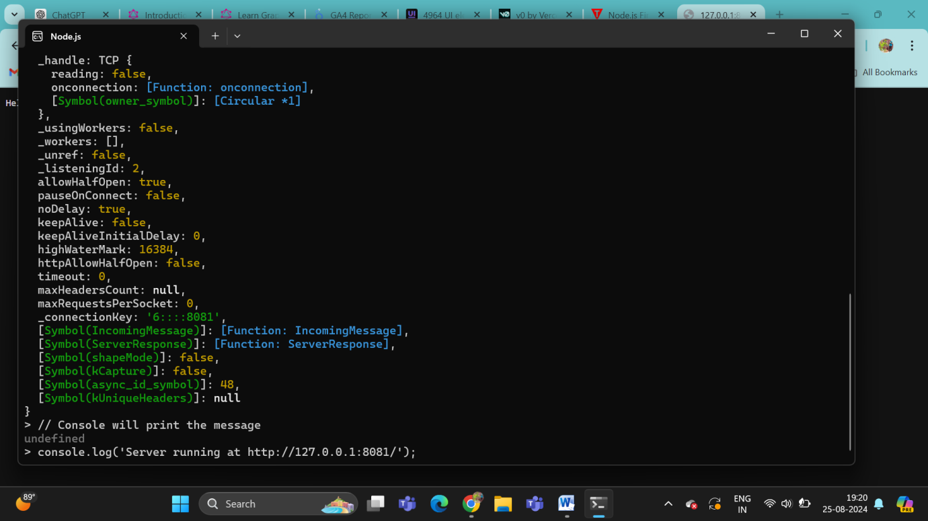  
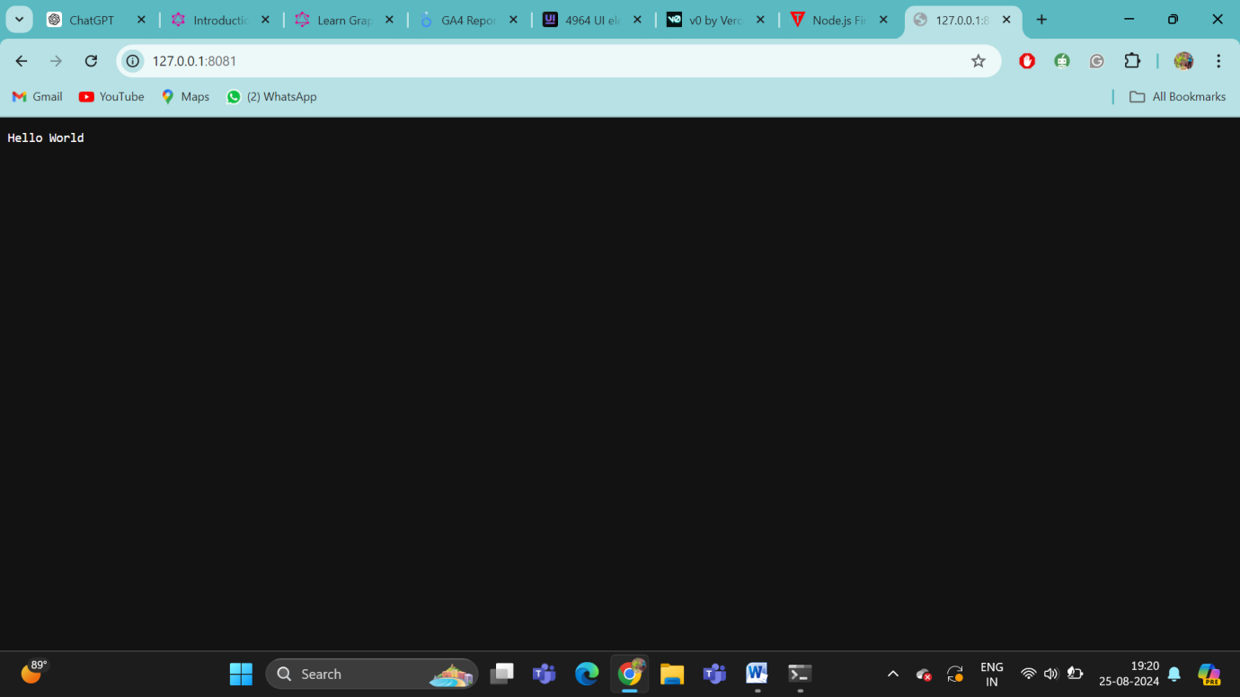

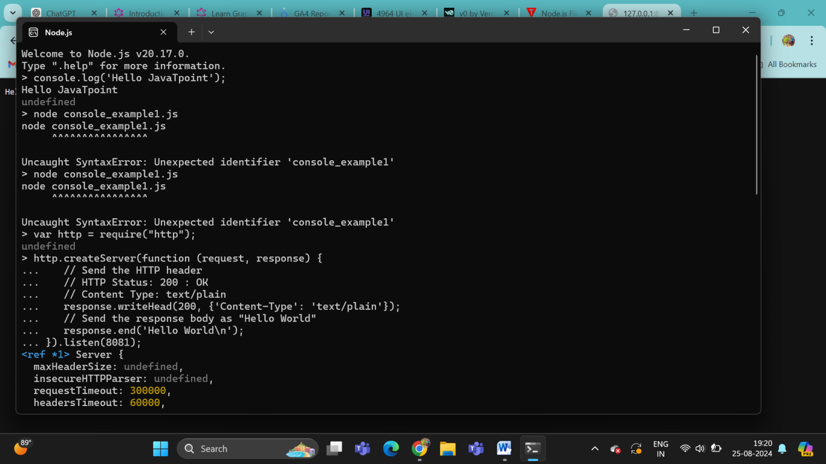

What is GRAPH QL ??

GraphQL is a powerful query language for APIs and a runtime for executing those queries by using a type system you define for your data. It was developed by Facebook in 2012 and released as an open-source project in 2015. GraphQL offers a more efficient, powerful, and flexible alternative to REST and ad-hoc web service architectures.

Here’s a detailed breakdown of the key concepts, components, and benefits of GraphQL:

**1. Core Concepts of GraphQL**

**a. Schema**

* **Definition:** A GraphQL schema defines the types of data that can be queried or mutated, and the relationships between these types. It serves as the contract between the client and the server.
* **Structure:** Schemas are written in GraphQL’s Schema Definition Language (SDL), which is a readable syntax to define types, queries, mutations, and subscriptions.
* **Example:**

graphql

Copy code

type Query {

user(id: ID!): User

posts: [Post]

}

type User {

id: ID!

name: String

email: String

}

type Post {

id: ID!

title: String

content: String

}

**b. Types**

* **Definition:** Types in GraphQL are the building blocks of the schema. They define the shape of the data that can be queried.
* **Common Types:**
  + **Scalar Types:** Basic data types like Int, Float, String, Boolean, and ID.
  + **Object Types:** Custom types that represent complex data structures, like User or Post.
  + **Enum Types:** Used for a fixed set of values, like Status { DRAFT, PUBLISHED }.
  + **List Types:** Represents a list of items, like [Post].
  + **Nullable and Non-Nullable Types:** By default, fields are nullable, meaning they can return null. To enforce non-nullability, an exclamation mark is used (ID!).

**c. Queries**

* **Definition:** Queries are used to read or fetch data from the server. A GraphQL query mirrors the structure of the response, which allows the client to specify exactly what data it needs.
* **Example:**

graphql

Copy code

query {

user(id: "1") {

name

email

}

}

* **Response:**

json

Copy code

{

"data": {

"user": {

"name": "John Doe",

"email": "john@example.com"

}

}

}

**d. Mutations**

* **Definition:** Mutations are used to modify data on the server (create, update, delete). They follow the same syntax as queries but are typically used to make changes to the data.
* **Example:**

graphql

Copy code

mutation {

createUser(name: "John Doe", email: "john@example.com") {

id

name

email

}

}

* **Response:**

json

Copy code

{

"data": {

"createUser": {

"id": "1",

"name": "John Doe",

"email": "john@example.com"

}

}

}

**e. Resolvers**

* **Definition:** Resolvers are functions that resolve the data for the fields in your schema. Each field in a GraphQL query maps to a resolver function that knows how to fetch the corresponding data.
* **Resolver Example:**

javascript

Copy code

const resolvers = {

Query: {

user: (parent, args, context, info) => {

return findUserById(args.id);

},

},

};

**f. Subscriptions**

* **Definition:** Subscriptions are a way to subscribe to real-time updates. They allow the server to send data to clients when a particular event occurs.
* **Example:**

graphql

Copy code

subscription {

postAdded {

id

title

}

}

* **Use Case:** Subscriptions are typically used for real-time features like chat applications, notifications, or live updates.

**2. Benefits of GraphQL**

**a. Efficient Data Fetching**

* **Overfetching and Underfetching:** Unlike REST, where you might receive too much or too little data, GraphQL allows clients to specify exactly what data they need, avoiding both overfetching and underfetching.

**b. Strongly-Typed Schema**

* **Type Safety:** GraphQL’s strongly-typed schema ensures that the API is self-documenting and provides clear expectations about what data is available and how it can be accessed.

**c. Single Endpoint**

* **Unified API:** Instead of having multiple endpoints for different resources (as in REST), GraphQL uses a single endpoint for all queries, mutations, and subscriptions, simplifying API design and consumption.

**d. Client-Driven Queries**

* **Flexible Data Retrieval:** Clients have complete control over the data they request. This flexibility is particularly useful for front-end developers who need to adapt data requirements as the UI evolves.

**e. Versionless API**

* **No Versioning Needed:** With GraphQL, APIs evolve without needing to create new versions. Deprecation mechanisms allow for gradual changes without breaking existing clients.

**3. GraphQL vs. REST**

| **Feature** | **GraphQL** | **REST** |
| --- | --- | --- |
| **Data Fetching** | Fetches exactly what is needed | Often leads to overfetching or underfetching |
| **Endpoint** | Single endpoint | Multiple endpoints for different resources |
| **Schema** | Strongly typed, introspectable | Typically documented separately |
| **Versioning** | No versioning required | Requires versioning (v1, v2, etc.) |
| **Real-time Updates** | Supports subscriptions for real-time updates | Requires additional protocols (e.g., WebSockets) |
| **Flexibility** | Highly flexible, client-driven queries | Fixed responses per endpoint |

**4. Common GraphQL Tools and Libraries**

**a. Apollo Client**

* A popular GraphQL client for managing local and remote data with support for queries, mutations, and subscriptions.

**b. Apollo Server**

* A GraphQL server that integrates with various JavaScript frameworks (like Express or Koa) and is used to build GraphQL APIs.

**c. GraphQL Playground**

* An interactive, in-browser GraphQL IDE that allows you to write queries, explore the schema, and see responses.

**d. Relay**

* A JavaScript framework developed by Facebook for building data-driven React applications using GraphQL.

**e. Hasura**

* A GraphQL engine that provides instant, real-time GraphQL APIs over a PostgreSQL database.

**5. Security Considerations**

**a. Query Complexity Analysis**

* Implementing mechanisms to prevent overly complex queries that could strain the server, such as limiting query depth or using query cost analysis.

**b. Authorization and Authentication**

* Ensuring that the API implements robust authentication and authorization checks within the resolver functions.

**c. Rate Limiting**

* Implementing rate limiting to protect the API from abuse or accidental overload by clients.